Information on COVID-19

What is COVID-19?

COVID-19 is an infectious disease caused by a newly discovered coronavirus strain that first emerged in China in December 2019.

In humans, several coronaviruses are known to cause respiratory infections ranging from the common cold to more severe disease.

The new coronavirus outbreak (COVID-19) was declared a pandemic by the World Health Organisation on 11 March 2020.

The most important symptoms of coronavirus (COVID-19) are recent onset any of the following:

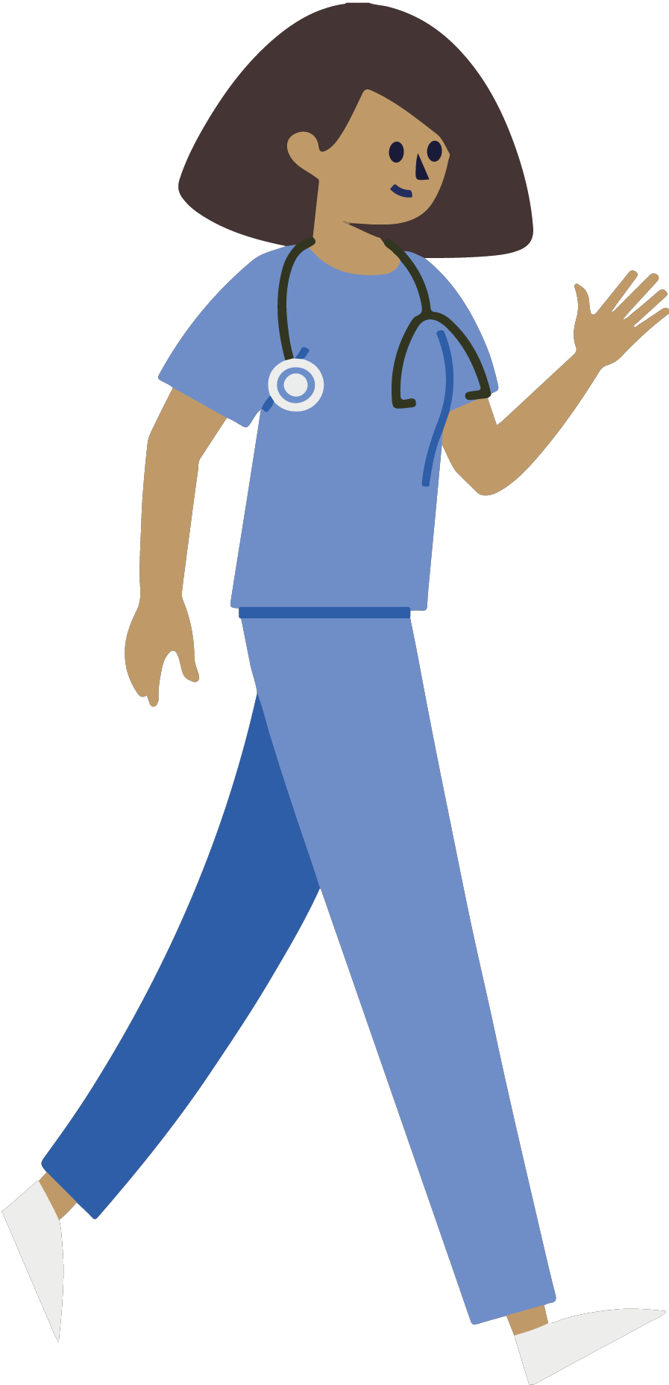a new continuous cough a high temperature
loss or change to your sense of smell or taste

of

For most people COVID-19 will be a mild illness. However if you have any of the symptoms listed you should self isolate at home.

After your visit to A&E or GP

You have been identified as having symptoms of COVID-19 infection

You need to go home and self isolate for seven days from the onset of your symptoms. If you live with others they need to isolate for 14 days from the onset of your illness. If anyone else in the household starts
displaying symptoms, they need to stay at home for 7 days from when the symptoms appeared, regardless of
what day they are on in the original 14 day isolation period.

What happens after my visit to A&E
or my GP?

At this point you are considered well enough to manage your symptoms at home. You will have been prescribed medication if required. If you did not require any prescribed medication then you should be able to manage your symptoms yourself. Ensure you stay hydrated and take paracetamol if you have a temperature. To aid recovery, try to avoid spending long periods of time lying flat in bed, trying sitting up or in a chair, or moving around at home.

You may have a cough or feel tired or
breathless for several weeks despite the COVID-
19 having cleared, however if the symptoms persist please call your GP for a review.

If you are still struggling to manage your symptoms at home, or your condition gets worse please contact:

Your care team may wish to give you some specific guidance below:

For a medical emergency, dial 999 immediately

When you get home

Can I spread COVID-19 to friends and family?

There is a risk that other members of your household or others that you have been in close contact with over the previous 2 weeks have been exposed to the virus but it is possible that they have not. Therefore each of you should follow the government's isolation guidance: https://www.gov.uk/government/publications/covid-
19-stay-at-home-guidance/stay-at-home-guidance-for- households-with-possible-coronavirus-covid-19- infection

Please continue to monitor this guidance as it is updated regularly as more evidence becomes available. This will ensure you have the most up to date information on when it is safe to end your self-
isolation (and household isolation if you live with others).

Please note that a persistent cough alone does not mean someone must continue to self-isolate beyond the duration advised by the government.
Can I get COVID-19 again?

You must also self-isolate again if someone you live with (or someone in your support bubble) gets symptoms again.You must self-isolate again even if you've had a positive test result for coronavirus before. You probably have some immunity to coronavirus but it's not clear how long it will last

Do I need to wear a facemask?
You may be issued with a mask to wear as you
travel home. Find the latest guidance regarding face masks here: https://www.gov.uk/government/publications/stayin g-safe-outside-your-home

What if I feel unwell again?
Monitor your symptoms regularly and if you have any concerns go to: https://www.nhs.uk/conditions/coronavirus-covid-
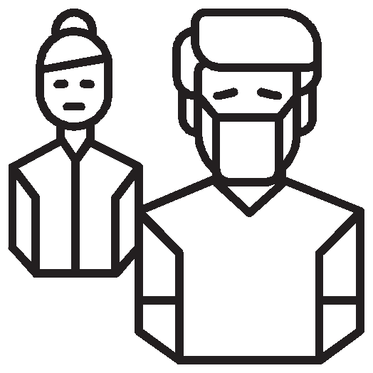19/check-if-you-have-coronavirus-symptoms/

Protecting yourself and others from coronavirus

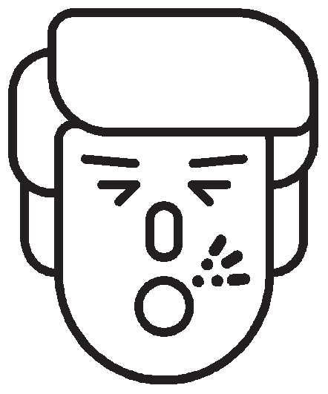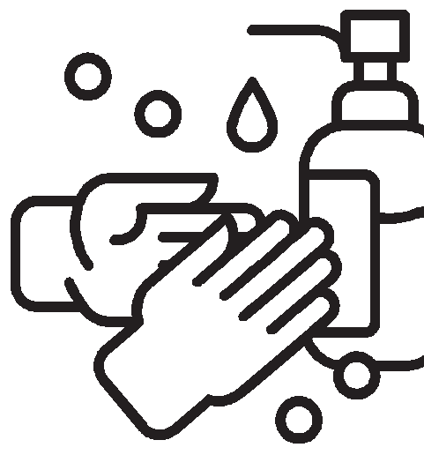

Wash your hands frequently and thoroughly, for at least 20 seconds. Use alcohol-based hand sanitizer if soap and water
aren’t available.
Cover your mouth and nose with a tissue when you cough or sneeze
and then throw the tissue in the bin and wash your hands. Alternatively, cough or sneeze into your elbow

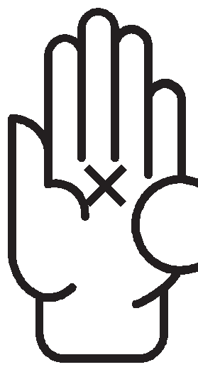Avoid touching your eyes, nose and mouth with unwashed hands

Avoid close contact
with people who are sick, sneezing or coughing.

